Scalable Framework for CI/CD Integration with SageMaker Pipelines for MLOps

Table of Contents
- Repository Template Structure
- Branching Strategy
  - Primary Branches
  - Dev Deployment Workflow
  - QC Deployment Workflow
  - Production Deployment Workflow
  - Hotfix Workflow
- ChatOps Integration in CI/CD
- Prod vs. QC Check for Deployment Validation
- Step Ladder Approach for SageMaker Pipeline Execution
  - Architecture Overview
- Global Utilities and Data Elements Process
  - Architecture Overview
  - Accessing Data Elements in Notebooks
  - Usage of Global Utilities in Notebooks
  - Comparison Between Traditional and Decoupled Global Utilities Approach
- Advantages of Framework

1. Repository Template Structure
A GitHub repository template called ds-mlops-template is used for all projects to maintain consistency and organization.

Repository Structure Overview
Each folder has a specific purpose:
- .github/workflows/ → Contains CI/CD workflow files for automation.
- certificates/ → Stores certificates required for SageMaker pipelines.
- config/ → Holds ML pipeline configuration files and environment variables.
- data/ → Contains project-specific data like SQL queries or datasets.
- doc/ → Includes documentation related to the project.
- notebooks/ → Contains Jupyter notebooks related to the project.
- reference/ → Stores knowledge base articles and reference materials.
- reports/ → Holds evaluation reports, figures, and analysis results.
- scripts/ → Includes ChatOps scripts used in the ML pipeline.
- src/ → Main source code folder.
  - src/resources/ → Stores common utilities used across projects.
  - src/python/ → Contains Jupyter notebooks converted python files.
- test/ → Holds test scripts for validating ML models.
- .version → Defines the project’s CI/CD version.
- CODEOWNERS → Specifies who has permission to modify different files.

2. Branching Strategy
A proper branching strategy is followed to manage development, testing, and deployment.
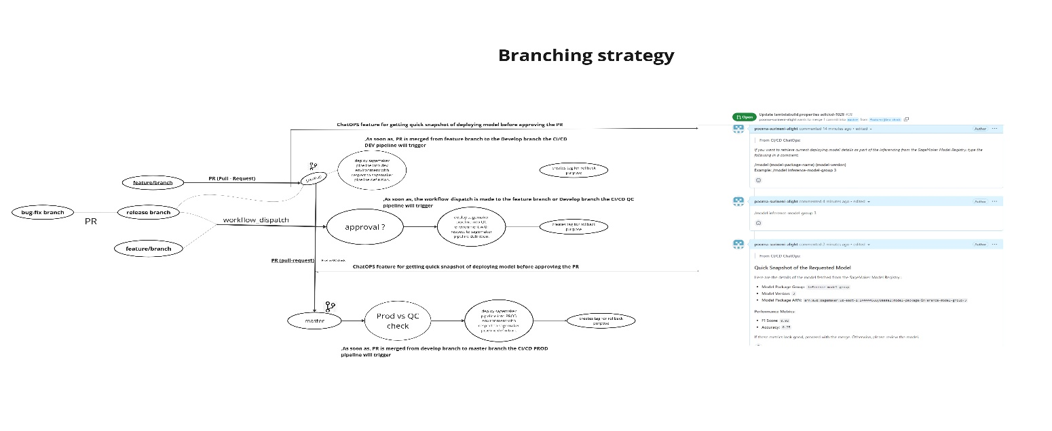

Primary Branches
- master – Final branch where only tested and production-ready code is merged.
- develop – Active development branch where new features are added.

Dev Deployment Workflow
- Developers create a feature branch from develop.
- Once changes are done, they create a pull request (PR) to merge into develop.
- The CI/CD workflow runs tests and validates the changes before merging.
- Once merged, the code is automatically deployed to the Dev environment.

QC Deployment Workflow
- A release branch is created from develop for testing.
- A bug-fix branch is created from the release branch if any issue is found.
- After fixing the issues, the changes are merged back into the release branch.
- The QC deployment is triggered using a workflow dispatch.
- Deployment to QC requires approval before going live.
- Once QC testing is successful, the release branch is merged back into develop.
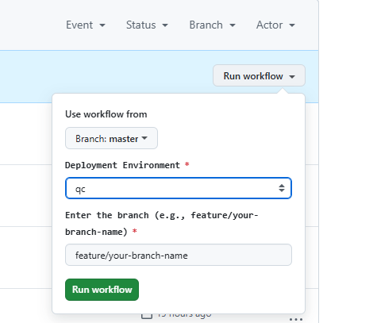

Production Deployment Workflow
- Once testing in QC is completed, changes from develop are merged into master.
- Merging into master automatically deploys the changes to production.
- A tag is created to track the deployment.

Hotfix Workflow
- A hotfix branch is created from master for urgent fixes.
- Any changes committed to the hotfix branch are directly deployed to production.
- The developer must merge the hotfix branch back into develop and master to keep everything in sync.

3. ChatOps Integration in CI/CD
ChatOps allows developers to run automation commands directly from GitHub PRs instead of running scripts manually.

How ChatOps Works?
- A developer enters a ChatOps command in a PR comment.
- GitHub workflows detect the command and run the corresponding script.
- The backend executes the script from the chatops/ directory.
- Results are posted as a reply in the PR.

ChatOps Directory Structure
- Scripts/chatops/model_chatops.py → Runs /model command to get model details.
- Scripts/chatops/evaluate_chatops.py → Runs /evaluate command to check test results.

Example ChatOps Commands
- /model {model-name} {version} → Fetches model version, F1-score, and accuracy.
- /evaluate {model-name} → Runs tests and posts results in the PR.
Advantages of ChatOps:
- Improves transparency by providing model evaluation insights directly in the PR.
- Ensures that all stakeholders can review model performance metrics before final deployment.

- Helps with easy troubleshooting.
• Suppose a model was deployed to production a long time ago, and someone wants to check its evaluation metrics.
• Instead of searching through logs or the SageMaker console, they can simply go to the PR and review the evaluation metrics right there.
So, this is how ChatOps helps simplify the ML deployment process, improves visibility, and makes troubleshooting much easier!”

4. Prod vs. QC Check for Deployment Validation
Before deploying code to production, a Prod vs. QC Check ensures that the commit was tested in QC first.

How It Works?
- When code is merged from develop to master, the CI/CD pipeline checks if the commit was already tested in QC.
- If the commit exists in QC, the deployment proceeds.
- If the commit was not tested in QC, deployment is blocked.

Why This Is Important?
- Prevents untested code from going live.
- Ensures production is always stable.
- Reduces risks of failures in production.

5. Step Ladder Approach for SageMaker Pipeline Execution

Architecture Overview
The MLOps pipeline follows a Step Ladder Approach, which means each step is processed one by one based on the configuration file (sagemaker-pipelines.json) stored in the config directory.
Whenever a developer commits a Jupyter Notebook into the src/notebooks/ folder, the backend system reads the pipeline configuration and runs each step accordingly.
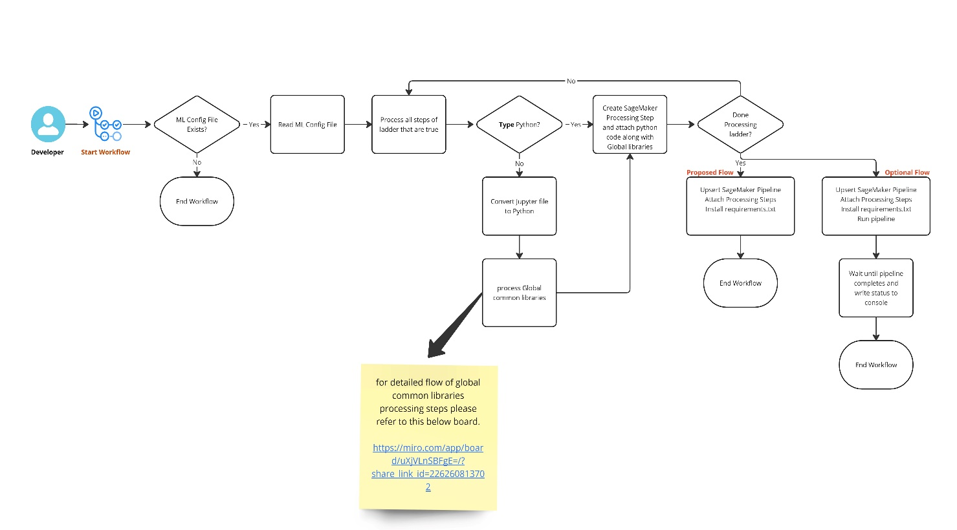

Pipeline Configuration (sagemaker-pipelines.json)
This JSON file defines how the ML pipeline should run.
Example structure:
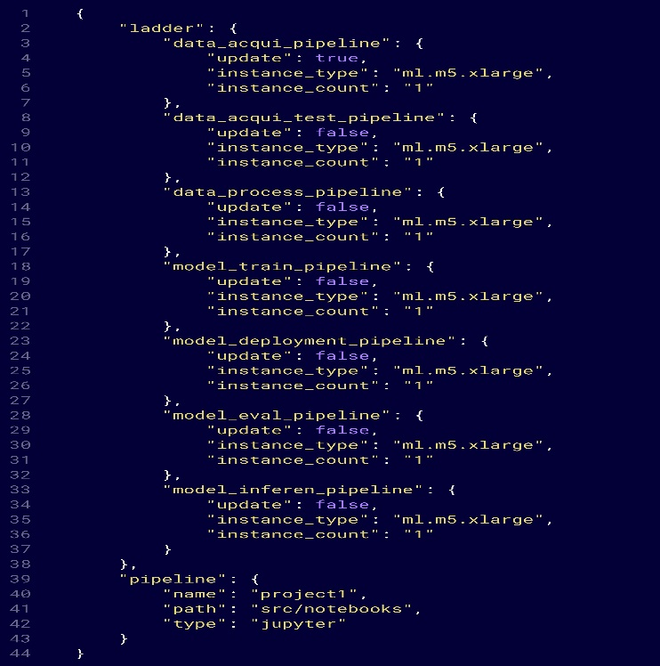

How It Works?
- The system checks if sagemaker-pipelines.json exists in the config directory.
  - If not found → End of workflow.
  - If found → Read the config file.
- It processes all steps marked as "update": true".
- For each step:
  - If a Python script with the step name exists, it runs that script.
  - If only a Jupyter Notebook exists, it converts it into Python (.py) using nbconvert and runs it.
  - Global libraries are attached to the script.
- Once all steps are processed, the SageMaker pipeline is created and triggered.
- The system waits for the pipeline to finish and logs the results.

6. Global Utilities and Data Elements Process

Summary
The ML Global Utilities and Data Elements approach simplifies a data scientist’s work by automating common steps like fetching secrets, establishing database connections, exporting data to Athena, registering models in the model registry, managing feature groups, and pushing data to a feature store—allowing them to focus on building models while leveraging this pre-built backend process for seamless integration and efficiency. These utilities can be utilized across different projects, ensuring consistency and scalability.

Architecture Overview
- The CI/CD pipeline looks into the data and src/resources/ directories and process each file present in it.
- Global utilities are stored in src/resources/.
- Project-specific data elements are stored in the data directory.
- These files are then pushed to the SageMaker session under opt/ml/processing/ path.
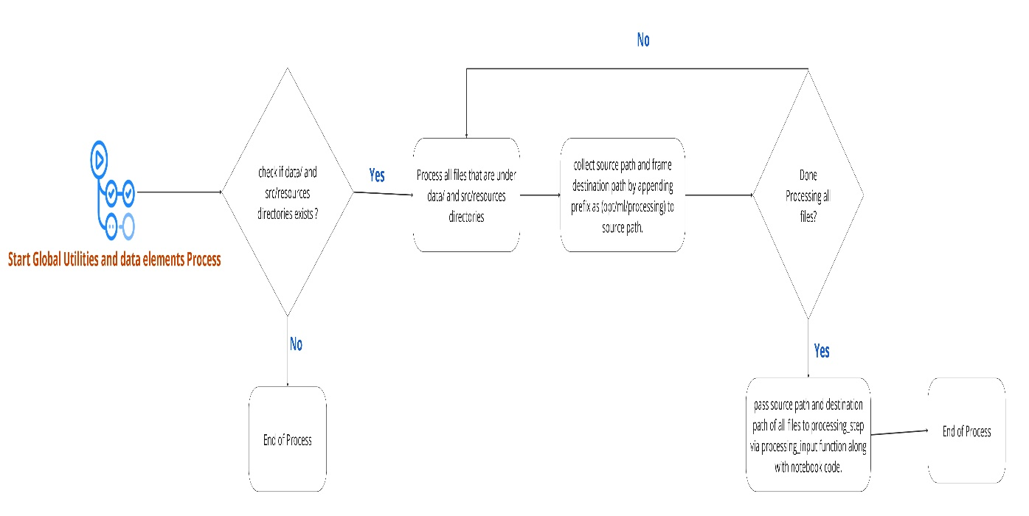

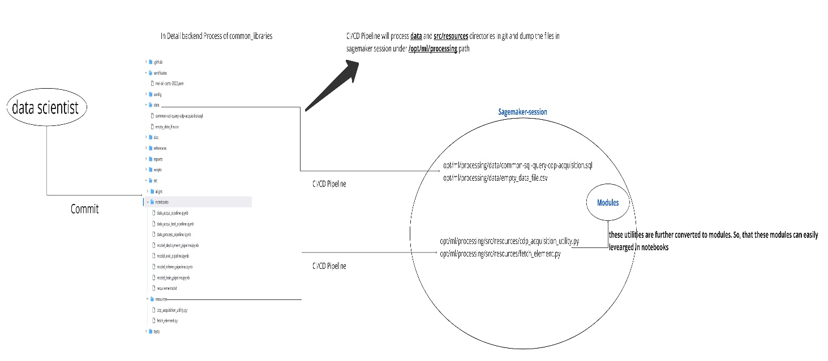
Accessing Data Elements in Notebooks
- Data elements are accessed using the load_element method.
Example:
from fetch_element import load_element
data = load_element("common-sql-cdp-acquisition.sql")
- This method ensures easy access to project-specific data.

Usage of Global Utilities in Notebooks
- Global utilities like fetching AWS secrets, getting connection parameters, and ODBC connections are stored in src/resources/.
Example:
from cdp_acquisition_utility import fetch_aws_secrets, get_connection_params, establish_odbc_connection
- This avoids writing the same code multiple times in every project.

Comparison Between Traditional and Decoupled Global Utilities Approach
- Traditional Approach:
  - Each project writes automated utilities for tasks like CDP_acquisition_utility (fetching aws secrets, building connection params, establishing pyodbc connection), CDP_export_utility (wrangler_s3_parquet), Athena_export_utility (Export data to athena catalogue).
  - Leads to repetitive code across projects.
- Decoupled Global Utilities Approach:
  - Now these automated utilities are stored once in a repository at src/resource directory.
  - Projects import the utilities into notebooks instead of rewriting them.

7. Advantages of Framework
- Scalability & reusability – Standardized repositories and global utilities.
- Automation – CI/CD ensures hands-free deployment.
- Transparency & tracking – ChatOps enables real-time insights.
- Improved productivity – Data scientists focus on ML, not infrastructure.
- Faster debugging and troubleshooting due to centralized utility management.
- Centralized control of Global utilities from a template repository.

